**3rd Anniversary Day of SDGs Marked in Nepal**

**Kathmandu, 25 September 2018**

Stakeholders including development experts on 25 September 2018 Tuesday marked the 3rd anniversary of the adoption of the Sustainable Development Goals (SDGs), stressing the need to invest more to meet the national targets by 2030.

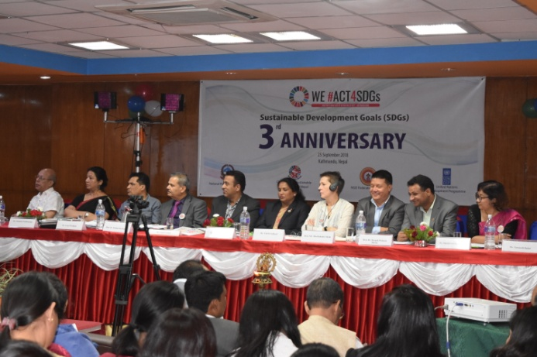At a joint programme organized by the National Planning Commission of Government of Nepal (NPC), NGO Federation of Nepal, CSO Forum on Sustainable Development in Nepal (Nepal SDGs Forum) and United Nations Development Programme (UNDP), speakers said while Nepal is on the frontlines in the process of localizing the SDGs, substantive investment is needed to make sure Nepal meets all the SDG targets.

The programme was inaugurated by Hon. Dr. Puspa Raj Kandel, Vice-Chair of National Planning Commission and chaired by Mr. Gopal Lamsal, president of NGO Federation of Nepal. Mr. Bhakta Biswokarma, Acting Chairperson of Dalit NGOs Federation welcomed to the guests and participants and highlighted about the programme schedule.

All countries across the globe, including Nepal adopted the SDGs on September 25, 2015 at the United Nations General Assembly, presenting a universal framework for development to be achieved in 15 years, from 2016 to 2030.

Government of Nepal was among the first countries in the world to publish SDG status report taking stock of the progress made in the past 15 years and setting national targets and indicators for the next 15 years.

The programme was begun with presentations of key development actors. First presentation was on "Progress of implementation of SDGs, challenges, potentialities and way forward", which was presented by Dr Naraya Raj Poudel, Programme Director of NPC. “All the development programmes of the Government of Nepal are now SDG-coded, which helps us track the progress made against each of the 17 Development Goals and targets,” he said. According to him, "NPC is taking stock of the progress made toward localizing the SDGs". "Localizing the SDGs at the local level is a challenge per se as Nepal is currently undergoing a complex process of federalization" he said.

Mr. Daya Sagar Shrestha, Executive Director of NGO Federation of Nepal was the second presenter. He highlighted "The roles of CSOs in SDGs' implementation and CSOs perspectives on SDG 16+". According to him, "Government has to do a lot to work on SDGs 16 and this goal should be taken as cross-cutting goal".

Similarly, the UN SDGs Advisor Mr. Gokarna Awasti spoke about the "Roles of UN Agencies to implement SDGs in Nepal". He said "UN Agencies are supporting to Government of Nepal in achieving SDGs".

After presentations, following persons spoke about the possible way-outs to address the issues and challenges related with development and Goal 16. Mr Kedar Khadka, Executive Director, GOGO Foundation spoke about "Accountable and inclusive public institutions and participatory decision making". Ms. Padmini Pradhananga, Secretary General, Transparency International Nepal spoke about "Corruption Control and Integrity". Mr. Taranath Dahal, Chief Executive, Freedom Forum spoke about "Access to Information and Fundamental Freedom". Ms Shanta Laxmi Shrestha, Chairperon, Beyond Beijing Committee highlighted about "the issues of gender equality related with SDGs". Mr. Gauri Pradhan, former member of National Human Rights Commission and International Coordinator, LDC Watch was another speaker, who put his views on "Human Rights, Rule of Law and Access to Justice". Hon. Dr. Deepak Prakash Bhatta, Member, House of Representative shade lights on "The Issues of Peace, Security and End of Violence in Nepalese context".

UN Resident Coordinator Valerie Julliand said the 17 SDGs are all interconnected and they cannot be separated. “The SDGs is a very ambitious agenda. More than a development agenda, they are a moral obligation, on all the governments, including the Government of Nepal,” she said adding that the government should work hand in hand with the civil society as they have the important role to monitor the government to make them accountable. The federalization is an additional opportunity to entrench the values of the SDGs at all levels in programming and decision making within the spirit of leaving no one behind, said the UN Chief.

Hon. Mira Devi Jairu, member of house of representative said "the points of suggestions expressed by the speakers would be guidelines and they will help to formulate laws and regulations of the governments of all levels". "Constitution should be taken as an opportunity to move the country towards prosperity" she added. Also she urged all the actors to keep eyes on province seven, where population of Dalits is high".

Hon. Min Bahadur Shahi member of National Planning Commission said "National Planning Commission is developing Leave No One Behind Index in Nepalese context". Mr Shahi added "Main thing to address the issues of marginalized peoples starts from realization".

Hon. Dr. Puspa Raj Kandel, vice-chair of National Planning Commission asked the CSOs to give the suggestions in written form. He said "Goal 16 is important because that governs other goals as well. He urged "CSOs, business sector, international agencies and people themselves to remain in discipline". He added "We need to increase production and employment within the country for sustainable economic growth". "Our culture, political practices, geography, and behaviors are also the determinant factors of our development" he argued.

Also speaking at the programme, CSO representatives expressed serious concern over slow progress in the areas of governance reforms, including anti-corruption and civic engagement.

During the programme 172 persons were present including representatives from National Planning Commission, Ministries, Constitutional Bodies, House of Representative, Local Government Associations, UN Agencies, Bilateral Development Partners, Multi-National Banks, European Union, Embassies, INGOs, CSOs and academicians. There was also an exhibition programme, where several organizations exhibited their publications, videos and shared their works that contribute in achieving SDGs.